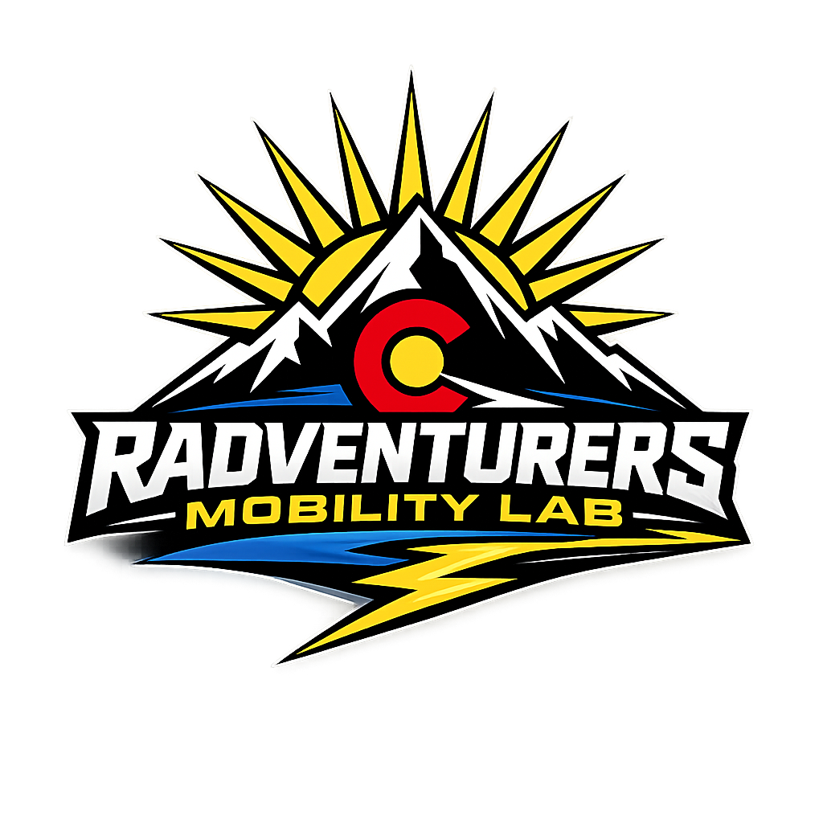

Mobility Lab
Product Portfolio
Executive Customer Reference Guide
What each product is. What it supports. What it does not do.
Official product imagery • key specifications • fit-for-task guidance • first-use education pathways

Built for customer conversations, demos, pilots, rentals, leasing and product selection.
Assistive technology does not replace PPE, safe-work procedures, clinical advice, or employer lifting policies.

PORTFOLIO AT A GLANCE
Start with the body area and task
Use this page to narrow the conversation. Final recommendations should follow an observed task review and supervised fit test.
PRODUCT | PRIMARY SUPPORT | TYPE | BEST STARTING POINT
Skelex 360 | Shoulders / arms | Passive | Overhead work; Welding & fabrication
Skelex Edge | Lower back | Passive | Bending; Lifting
Skelex Neck | Neck / head | Passive | Upward-looking inspection; Overhead assembly
Hypershell X Series | Hips / legs | Powered | Long-distance walking; Hiking / mixed terrain
DNSYS X1 Series | Hips / legs | Powered | Walking & hiking; Longer-distance mobility / endurance
DNSYS Z1 Series | Knees | Powered | Stairs & steep slopes; Hiking / demanding terrain
Shift Moonwalkers | Feet / gait speed | Powered footwear | Large campuses; Long facility walking routes
German Bionic Exia | Back / whole task | Powered AI | Logistics & distribution; Manufacturing / construction

PASSIVE SYSTEMS: No motors or batteries. Mechanical structures redistribute or counterbalance load while the user performs the movement.
POWERED SYSTEMS: Motors, sensors and batteries add timed assistance. The user remains responsible for balance, direction and safe task execution.

SKELEX
Skelex 360
Shoulders / arms • Passive
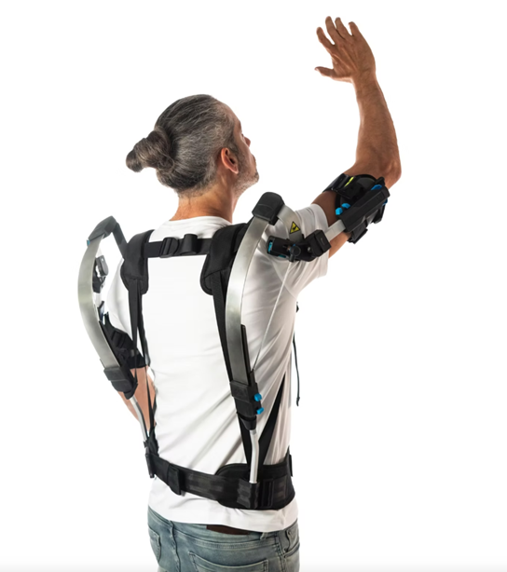 | BEST FIT  - Overhead work  - Welding & fabrication  - Aircraft / automotive assembly  - Construction & installation  KEY SPECIFICATIONS  - Passive  - Shoulders & arms  - Mechanical gravity balancing  - Broad overhead / front-facing motion

WHAT IT DOES  - Supports arm weight during elevated tasks  - Reduces shoulder / upper-body demand  - No battery, charging or software required  - Can integrate with Skelex Neck | WHAT IT DOES NOT DO  - Does not lift objects independently  - Does not increase safe load limits  - Not a powered strength suit  - Not a medical / rehabilitation device

CUSTOMER TAKEAWAY A strong starting point for overhead work.
FIRST-USE PATHWAY: Set belt length snug and symmetrical over the hips. • Put it on like a backpack: hip belt, chest strap, shoulder straps, then arm cups. • Inspect frame, straps, cups and adjustment points before each shift. • Do not treat support force as added lifting capacity.

SKELEX
Skelex Edge
Lower back • Passive
BEST FIT
- Bending
- Lifting
- Low-height work
- Floor-level picking & stocking

KEY SPECIFICATIONS
- Passive
- Lower back
- Bending, kneeling, lifting
- Thigh / knee configuration

WHAT IT DOES  - Supports the lower back in bent postures  - Works without motors or batteries  - Allows mobile work and task changes  - Uses thigh or knee anchoring by configuration | WHAT IT DOES NOT DO  - Does not motorize a lift  - Does not replace ergonomic controls  - Does not change safe lifting limits  - Not a medical back brace

CUSTOMER TAKEAWAY A strong starting point for bending.
FIRST-USE PATHWAY: Use the current Edge quick-start/manual to assemble the correct thigh or knee anchoring configuration. • Begin with unloaded bends and floor-level reaches in a clear area. • Inspect elastic elements, webbing, anchors and fasteners before use. • Do not use the device to justify heavier lifts.

SKELEX
Skelex Neck
Neck / head • Passive
BEST FIT
- Upward-looking inspection
- Overhead assembly
- Agriculture
- Maintenance / installation

KEY SPECIFICATIONS
- Passive
- Max support force 5 kg
- Weight 0.15 kg
- One size

WHAT IT DOES  - Supports head weight during upward-looking work  - Moves with the user rather than locking the neck  - Can pair with other Skelex systems  - No battery required | WHAT IT DOES NOT DO  - Not a cervical collar  - Does not medically stabilize the spine  - Does not treat neck injury  - Does not add lifting power

CUSTOMER TAKEAWAY A strong starting point for upward-looking inspection.
FIRST-USE PATHWAY: Choose the manufacturer-approved belt or chest-strap wearing configuration. • Test short upward-looking movements before sustained overhead work. • Inspect the support, straps and contact surfaces before use. • This is not a cervical collar or medical stabilization device.

HYPERSHELL
Hypershell X Series
Hips / legs • Powered
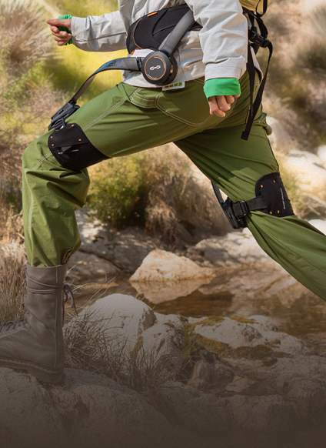 | BEST FIT  - Long-distance walking  - Hiking / mixed terrain  - Outdoor recreation & travel  - Active-user endurance support  KEY SPECIFICATIONS  - X Pro S / X Max S / X Ultra S  - Up to 1000 W, model-dependent  - Up to 30 km, model-dependent  - IP54 on higher configurations

WHAT IT DOES  - Adds powered hip assistance  - Adapts to movement using sensors / software  - Offers terrain-specific modes by model  - App-based control and customization | WHAT IT DOES NOT DO  - Does not balance or walk for the user  - Not a medical device  - Not for users unable to walk independently  - Range / power vary by model and conditions

CUSTOMER TAKEAWAY A strong starting point for long-distance walking.
FIRST-USE PATHWAY: Use the Hypershell+ app height/weight recommendation as a starting point. • Read the current X Series manual and pair/configure the app before first use. • Charge only with compatible equipment and follow the current battery/storage instructions. • The user must be able to walk and balance independently.

DNSYS
DNSYS X1 Series
Hips / legs • Powered
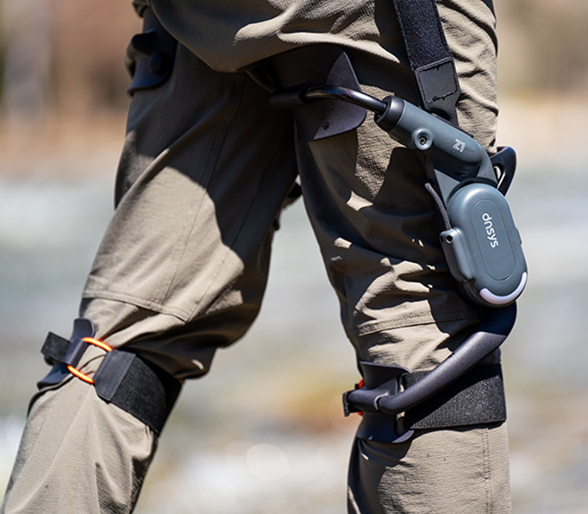 | BEST FIT  - Walking & hiking  - Longer-distance mobility / endurance  - Stairs and slopes for independently mobile users  - Customers comparing lighter vs. extended-range configurations  KEY SPECIFICATIONS  - X1 Lite / Carbon / Carbon Pro / X1+Z1  - Up to ~900 W class  - 15 km base; Carbon Pro up to 30 km with two batteries  - Model-dependent materials and range

WHAT IT DOES  - Motorized hip assistance synchronized to gait  - Adaptive assist plus controlled resistance / training modes  - Swappable X1 Smart Battery system  - Model choices for weight, materials and range | WHAT IT DOES NOT DO  - Does not provide balance support or walk for the user  - Not a medical / rehabilitation device  - Requires independent walking, leg lift and balance  - X1 batteries / chargers are not interchangeable with Z1 hardware

CUSTOMER TAKEAWAY A strong starting point for walking & hiking.
FIRST-USE PATHWAY: Confirm all X1 components are present and connect the X1 Smart Battery as shown in the manual. • Install/connect the DNSYS app where required, then power on and complete first-use setup. • Use only X1-compatible battery/charger hardware; X1 and Z1 batteries are not interchangeable. • Independent walking, leg lift and balance are required.

DNSYS
DNSYS Z1 Series
Knees • Powered
BEST FIT
- Stairs & steep slopes
- Hiking / demanding terrain
- Sit-to-stand and squat assistance
- Knee-focused or combined hip + knee support

KEY SPECIFICATIONS
- Dual Joint / Dual Joint Pro / Z1 + X1
- Up to 50% motion assist
- Up to 15 km base; selected Pro configurations up to 30 km
- Approx. 680 g per leg on Dual Joint

WHAT IT DOES  - Adds powered assistance at the knee joint  - Supports ascent, descent, standing and squat-type movement  - Uses multi-sensor AI movement recognition  - Can pair with X1 in supported combined configurations | WHAT IT DOES NOT DO  - Does not provide independent balance  - Not a medical treatment or rehabilitation device  - Requires independent walking and normal leg-lifting ability  - Uses Z1-specific battery / charging hardware

CUSTOMER TAKEAWAY A strong starting point for stairs & steep slopes.
FIRST-USE PATHWAY: Fit the belt and left/right knee units as shown in the Z1 manual, aligning the joint with the knee. • Begin on level ground and learn standing, walking and controlled knee assistance before stairs or slopes. • Use Z1-specific PowerPlus battery/charging hardware. • Independent balance and normal leg-lifting ability are required.

SHIFT ROBOTICS
Shift Moonwalkers
Feet / gait speed • Powered footwear
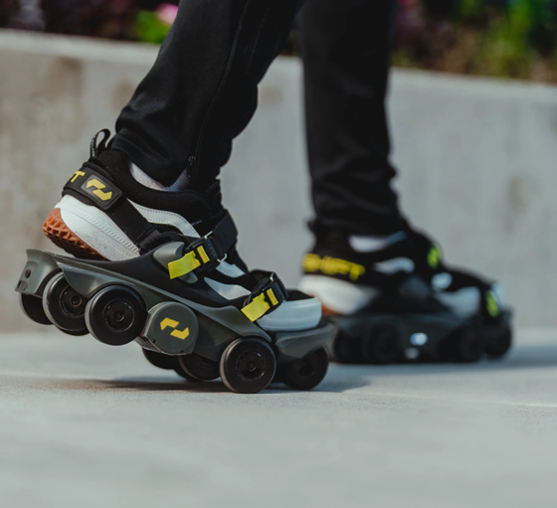 | BEST FIT  - Large campuses  - Long facility walking routes  - Controlled productivity pilots  - Recreation / mobility experimentation  KEY SPECIFICATIONS  - Top speed 7 mph  - Average range ~7 miles  - 5.3 lb each  - 400 W / 10 Nm guide reference

WHAT IT DOES  - Gait-based powered acceleration  - Hands-free acceleration / deceleration  - Rugged 8-wheel original design  - App-based setup and customization | WHAT IT DOES NOT DO  - Does not support the back, hips or knees  - Not self-balancing  - Not appropriate for every floor / crowd / stair  - Not a medical mobility device

CUSTOMER TAKEAWAY A strong starting point for large campuses.
FIRST-USE PATHWAY: Use compatible closed-toe shoes and secure each Moonwalker firmly with the straps. • Start on a flat open surface, walk slowly and use Training mode while learning the response. • Charge with the approved charger/USB-C setup and inspect wheels, straps and housings before use. • Avoid stairs/escalators and uncontrolled surfaces during use/training.

GERMAN BIONIC
German Bionic Exia
Back / whole task • Powered AI
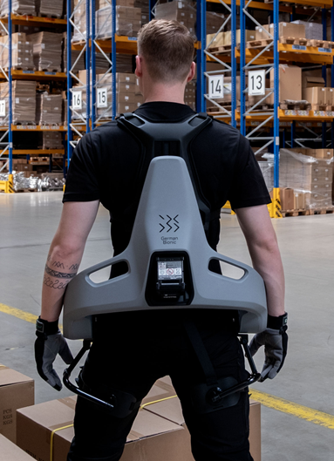 | BEST FIT  - Logistics & distribution  - Manufacturing / construction  - Baggage / material handling  - Healthcare / nursing support tasks  KEY SPECIFICATIONS  - Up to 38 kg / 84 lb assistance  - Lift / lower / walk / carry / bend  - Augmented AI / ML  - Connect app + German Bionic IO

WHAT IT DOES  - Up to 38 kg / 84 lb dynamic lift assistance  - Assists lifting, carrying, walking and bending  - Learns and adapts using AI / ML  - Connects to app and fleet / ergonomics platform | WHAT IT DOES NOT DO  - Does not autonomously carry objects  - 84 lb is assistance — not a new safe lifting limit  - Does not replace required hoists / PPE  - Results depend on fit, task and training

CUSTOMER TAKEAWAY A strong starting point for logistics & distribution.
FIRST-USE PATHWAY: Exia should be fitted through German Bionic/authorized-partner training rather than by guessing from a generic web guide. • Complete supervised onboarding and learn task-specific assistance for lifting, lowering, carrying, walking and bent-over work. • Use approved batteries/charging and follow the current hot-swap, storage and service instructions provided with the unit. • Do not interpret the 38 kg assistance figure as a new safe lifting limit.

FAST SELECTION GUIDE
Start with the problem to solve — not the product
Use this as a first-pass decision tool before a site review or demo.
CUSTOMER NEED | START HERE | WHY
Shoulder fatigue from overhead work | Skelex 360 | Passive shoulder support; no battery
Lower-back fatigue from bending / lifting | Skelex Edge | Lightweight passive support
Neck fatigue from looking up | Skelex Neck | Dedicated head / neck support
Walking / hiking endurance | Hypershell X Series / DNSYS X1 Series | Powered hip assistance
Knee-demanding stairs / slopes | DNSYS Z1 Series | Powered knee-focused support
Faster walking between locations | Shift Moonwalkers | Powered walking accelerator
High-intensity industrial lifting | German Bionic Exia | Powered adaptive industrial assistance

BEFORE A DEMO OR PILOT
- Observe the exact task and identify the body area under load.
- Confirm user fit range, clothing / PPE compatibility, and manufacturer exclusions.
- Use a controlled first fitting and low-risk practice area.
- Never translate an assistance figure into a new safe lifting limit.
- Document the exact model, software / firmware generation, and settings used.
- Measure useful outcomes: exertion, posture, fatigue, cycle time, comfort, adoption, and new hazards.

